Face time vs. screen time: The technological impact on communication
By Chandra Johnson, Deseret News National Edition
Published: Friday, Aug. 29 2014 4:45 a.m. MDT
Updated: Wednesday, Sept. 3 2014 10:30 p.m. MDT

Share339 Share268 Tweet15 1 0
While there are more ways than ever to communicate, some are concerned about the break-neck speed our language is evolving, but some scientists are using technology to help us communicate better.
Shutterstock
Enlarge photo»
Summary
Word or emoji? Face or screen? There are more ways than ever to communicate, but some experts are concerned that too much reliance on less-direct forms of communication could be bad for children and families.
NATIONAL EDITION
This story is part of theDeseret News National Edition, which focuses on the issues that resonate with American families.
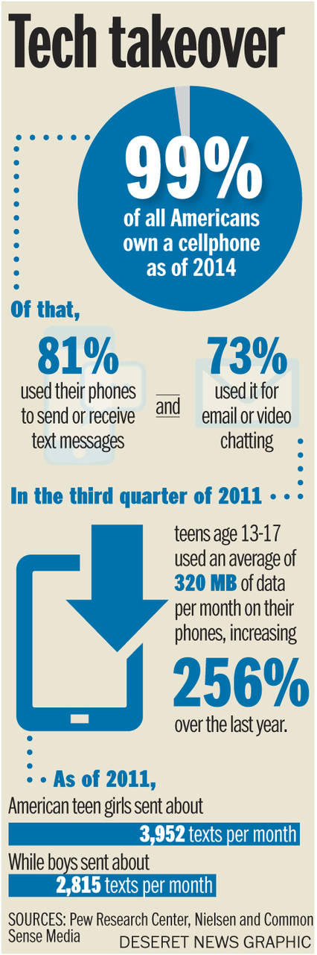

Marc Brackett didn’t become the director of Yale University’s Center for Emotional Intelligence out of curiosity about emotions.
He got there after being bullied in school, followed by years of therapy.
"My primary influence was being a kid who was bullied and didn’t know how to deal with it effectively," Brackett said. "I realized that if I had the skills to understand and manage my feelings, I could overcome anything."
Today, Brackett uses a specially developed app and classroom curriculum to help people use technology to better articulate, understand and control their emotions.
That ability to understand and catalogue emotions is more important than ever since the advent of the Internet, social media and texting. When Brackett was growing up, there was no Facebook for venting, no emoji catalog to illustrate his feelings, no online community to listen. But in an age with more methods than ever to talk online, researchers are now studying whether this is changing the way people communicate.
They're finding that people communicate more often with family and friends because of technology, but the quality of that communication may be weaker. Kids who spend more time engaging with a screen than with other kids or adults can struggle to understand emotion, create strong relationships or become more dependent on others.
"These kids aren't connecting emotionally," says parenting expert and pediatric nurse Denise Daniels. "Emails, texts — these lack the emotive qualities of face-to-face interaction."
"What’s the balance? If all you’re doing is using Facebook, you're not getting the interpersonal connection you need," Brackett said. "Kids want to be hugged and touched, they don’t want to be texted. There's a basic need to fill that social bond."
Does a friendly emoji replace a hug or even a phone call? Probably not, psychologist Jim Taylor says, and the divide is becoming very real within families.
"Kids are spending so much time communicating through technology that they’re not developing basic communication skills that humans have used since forever," Taylor said. "Communication is not just about words."
Smile vs. :)
For Dr. Kate Roberts, a Boston-based school psychologist, people who increasingly rely on technology to communicate are paying a heavy price society is just beginning to understand.
"Families text rather than have conversations. We're living in a culture of sound bites, and that is not developing our verbal skills or our emotional intelligence," Roberts said. "We're down on the interaction time. Right now, at Boston College, there's a course on how to ask a person out on a date. It's like we've lost the skill of courtship and the ability to make that connection."
For adults, Roberts believes reliance on the quick text or Facebook message is mostly about saving time. She calls them "digital shortcuts." But for children, the overuse of technology to communicate affects the brain, Daniels says.
"Technology can be a big hindrance on interpersonal relationships," Daniels said. "For all its benefits, technology can completely rewrite a child's brain pathways in a very different way than how they would normally develop."
Daniels is talking about neurotransmitters — chemicals in the brain that relay information between nerves. A developing child is born with pathways that expand based on stimulation like a parent's voice, music, touch and eventually play. They also help children file and organize endless pieces of information gathered as they age. But for children who spend too much time interacting through a screen, something happens, Daniels says.
"Their neural pathways change and different ones are created. It affects concentration, self-esteem, in many cases they don’t have as deeply personal relationships," Daniels said. "They lose empathy. We've seen kids like this that don't develop those sympathetic and empathetic skills they need."
Think of it as the difference between looking at a picture of cool, green grass and actually walking barefoot in it. The problem is that the more people and children interact with a person or the real world through a screen rather than in real life, the less emotion is attached to the exchange.
Time limits for technology are relative for everyone, Daniels said. While the American Association of Pediatrics recommends no screen time of any kind for kids under age 2, Daniels says not allowing kids of age any screen time is futile.
"After age 2, it's just part of their life," Daniels said.
Emotionally speaking, whether it's a child exploring the world with their hands and feet or reading another person's face, technology is a poor substitute for the real thing, Roberts says.
"There's a big disconnection going on here that's very real for some people," Roberts said. "When people aren't using face-to-face contact for personal issues, it doesn't fill the intimacy need. For all the strong reaction out there about Twitter and Facebook allowing emotional expression, it's not necessarily effective. You're not necessarily getting to a resolution like you would (with another person)."
Emojis, as Taylor pointed out, were invented partially to address the void of not being able to read the facial expressions behind text-based communication.
"Emoticons just don’t do emotions justice, but they’re an attempt to add what’s missing," Taylor said. "Voice inflection, body language, facial expression and the pheromones (released during face-to-face interaction): These are all fundamental to establishing human relationships. And they’re all missing with most forms of modern technology."
Emotional attachment
Not all technology inhibits emotional exchanges. Brackett and Daniels pointed out that face-to-face technology like Skype can actually augment relationships.
"Many of my students are foreign and can’t see their families," Brackett said. "For them there's nothing better than being able to stay in touch online. It's very good in that way."
Researcher Katie Davis found technology to be a double-edged sword for teenagers who communicate often with their parents through technology as she researched and co-authored the book "The App Generation." Davis interviewed students and professionals who worked with children to find out how technology impacted kids.
"There’s a risk aversion that they seem to display in various parts of life. Many of them were fearful of getting the wrong answer when entertaining questions that require a long answer," Davis said. "It also crossed into relationships as a hesitancy to take risks in one’s relationships. They found it easier to communicate through a screen."
Teens also exhibited a "hyper connection" to their parents. Davis' book cited a study from Middlebury College that found that teens were in contact with their parents at least 13 times per week via technology.
"In some ways, that’s a good thing. On the other hand, it's important to find out who you are apart from your parents," Davis said. "If you’re looking back to them too much, it doesn’t provide a lot of room to find out who you are on your own."
Daniels said parents and kids have yet to find the sweet spot for communicating via technology, and too often people settle for a quick text rather than a conversation.
"Kids need that face-to-face time," Daniels said. "If you abbreviate your emotions with technology, you're living an abbreviated life."
Language barrier
Taylor says emotional problems with nonfacial online communication are made worse in families where there can be what he calls a digital language barrier.
"Children and parents are speaking very different languages now: one analog and one digital. Parents often aren’t fluent in digital language," Taylor said. "Because parents are not speaking digital, the dinner table talk can suddenly be like someone speaking Spanish to someone who doesn’t."
The trouble for parents, as Toronto-based linguist Heather Lotherington says, is that the digital language is also changing faster than language ever has.
"Language changes over time," Lotherington said. "But the changes are happening faster now. In the old days, we had letters. Now we have conversations in nanoseconds."
And with more mechanisms to communicate coming out all the time, methods of digital communication develop at light speed by comparison. One example? The first chat room was invented at the University of Illinois in 1973 using a computer system called PLATO. Less than 20 years later, in 1992, the first mobile text message was sent. By 2010, the world was sending about 193,000 texts per second, Gizmodo reported.
"Technology has been with us since our cave days. Things like the alphabet and the ballpoint pen were huge moments in communication," Lotherington said. "So this is a big moment in history for us, being able to communicate digitally in so many ways. But it also moves us into an era where we've made huge quantum leaps without thinking too much."
Lotherington and Roberts are both concerned about how easy it is for people to use the technology instead of interacting more directly without thinking about what — or who — they're losing meaningful connection within the process, be it their parents, children or spouses.
"Technology should make communication easier when it's appropriate," Roberts said. "But when we have access (to more direct forms of communication), we don't use it. Part of it is just that it's human nature to avoid. It's easier."
Finding a balance
For the potential problems it presents, experts agree that technology itself is not a bad thing, but how it's used can be cause for concern.
Limits are crucial for entire families — not just for young children.
"Place a value on one-to-one interaction," Taylor said. "Having family time and meals where everyone is disconnected is a great way to start. Kids hate double standards, so parents need to be that example."
At the same time, it's incredibly important, Daniels says, for parents to keep up with what their kids use to express themselves online.
"Technology is here to stay. Parents have to moderate their time and really know their child. Is there an imbalance between their online and experiential learning? Is it affecting their mood?" Daniels said. "As parents, we have to ask these questions."
But just because kids are accustomed to devices or may need them to do schoolwork is no reason not to lay down ground rules.
"Parents need to just suck it up and be strict about enforcement," Roberts said. "A lot of times this is an issue of a lack of oversight. Children will always challenge parents. That’s their role."
Above all, Lotherington said, realize that communication evolves and children will be part of the shift.
"We've changed," Lotherington said. "And the changes are here to stay."
Email: chjohnson@deseretnews.com
Twitter: ChandraMJohnson

