Ask 5 students who are not in your contact list what their phone number is
Name | Phone number

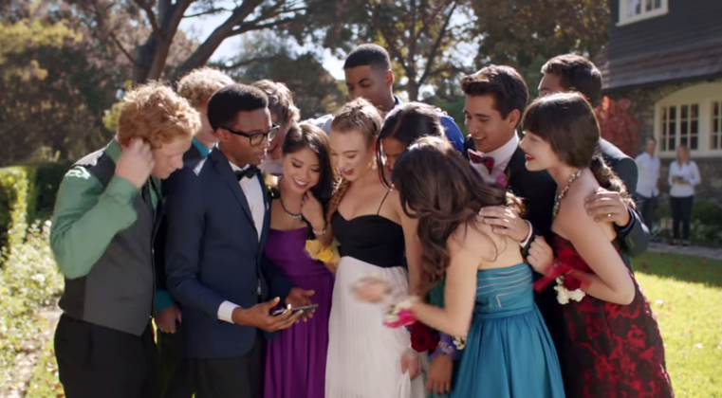
“Yeah, but you gotta give me your number, though”

In a group of 2 people, make up a skit in which one person successfully gets the other person’s phone number

