Creating a Google Doc
Log into your Gmail account

- Username = skywardusername@alpinesd.org
  - quantmar000@alpinesd.org (For example)
  - Password = one or two zeros plus your lunch number (six digit lunch number gets two zeros)
    - 01234567
    - 00123456
- Once you are logged in, some of you will have to hit continue because it will be the first time you have used it. Hit that button.
- You are now in your email. Congratulations.

Creating a Google Doc

- Look at the top right part of the screen. Click on the grid (group of small boxes)

See it? Yay!

  - 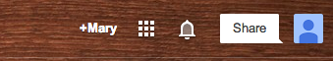

  - Once you click on the boxes, click on the icon that says “Drive.” It’s blue, yellow, and green and looks like a triangle.

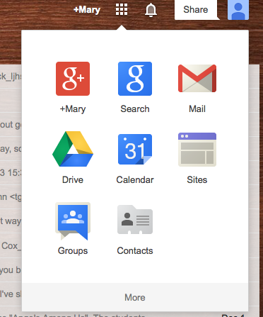

- On the left part of the screen, you will see a red button that says “Create”. Click it.

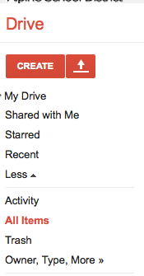

- Click “Document.” You will go to a document and can begin typing. It will save automatically every few seconds.

