CHINESE AND DANCE CO. PRESENT…
The Chinese New Year Flex Assembly!
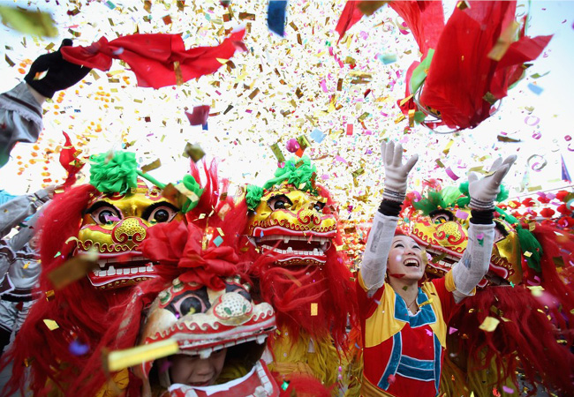
2015 YEAR OF THE RAM

Thursday February 19th
COLORED TICKETS ONLY
There will be songs, dances, speeches, and skits!

YOU WON’T WANT TO MISS THIS!
謝謝，再見！

